Peer to Peer Messaging app

User Interface Mockup

Connor Cuffe

Beaumaris secondary College

Table of Contents

# User interface Mockup

## Mockup 1

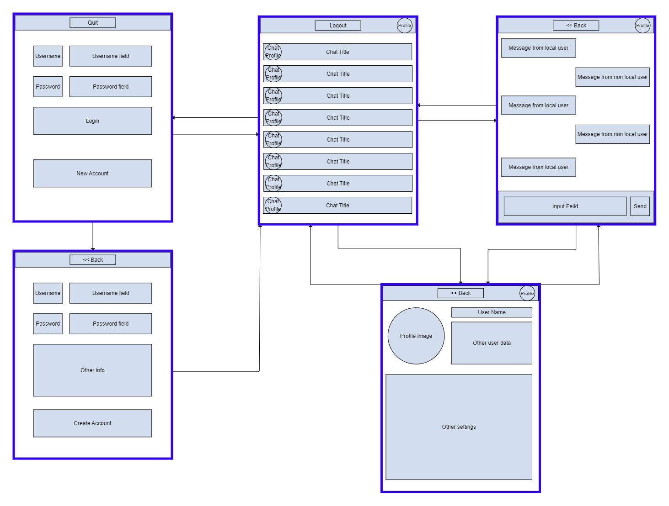

### Evaluation

#### Pros

* Similar to other messaging apps
  + Therefore, easy for users to migrate to.

#### Cons

## Mockup 2

### Evaluation

#### Pros

#### Cons

## Mockup 3

### Evaluation

#### Pros

#### Cons

## Final Decision